Knight's Travails

Choose one of these alternatives and explore how they can outperform other widely-used BSTs in different scenarios.

Dalam melakukan access, search, insertion, deletion AVL tree akan lebih unggul dibandingkan dengan BST karena time complexity dari AVL tree hanya O(Log(n)) sedangkan BST membutuhkan O(n).

|  |  |  |  |  |  |  |
| --- | --- | --- | --- | --- | --- | --- |
| 41 | 42 | 43 | 44 | 45 | 46 | 47 |
| 35 | 36 | 37 | 38 | 39 | 40 | 41 |
| 28 | 29 | 30 | 31 | 32 | 33 | 34 |
| 21 | 22 | 23 | 24 | 25 KNIGHT | 26 | 27 |
| 14 | 15 | 16 | 17 | 18 | 19 | 20 |
| 7 | 8 | 9 | 10 | 11 | 12 | 13 |
| 0 | 1 | 2 | 3 | 4 | 5 | 6 |

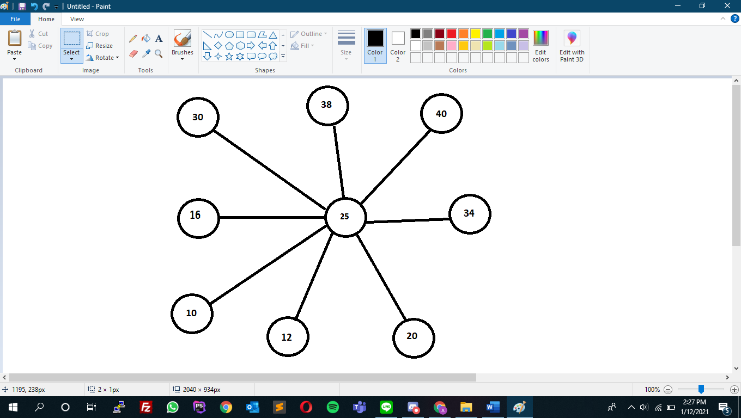

Disjoint Set & graph

Kruskal Algorithm

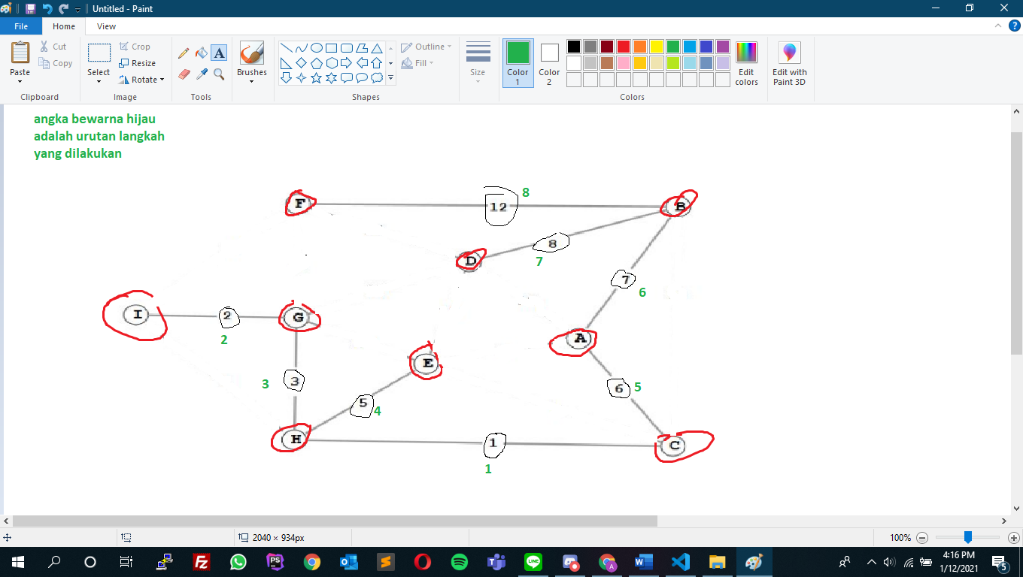

Total cost = 44

Prim Algorithm

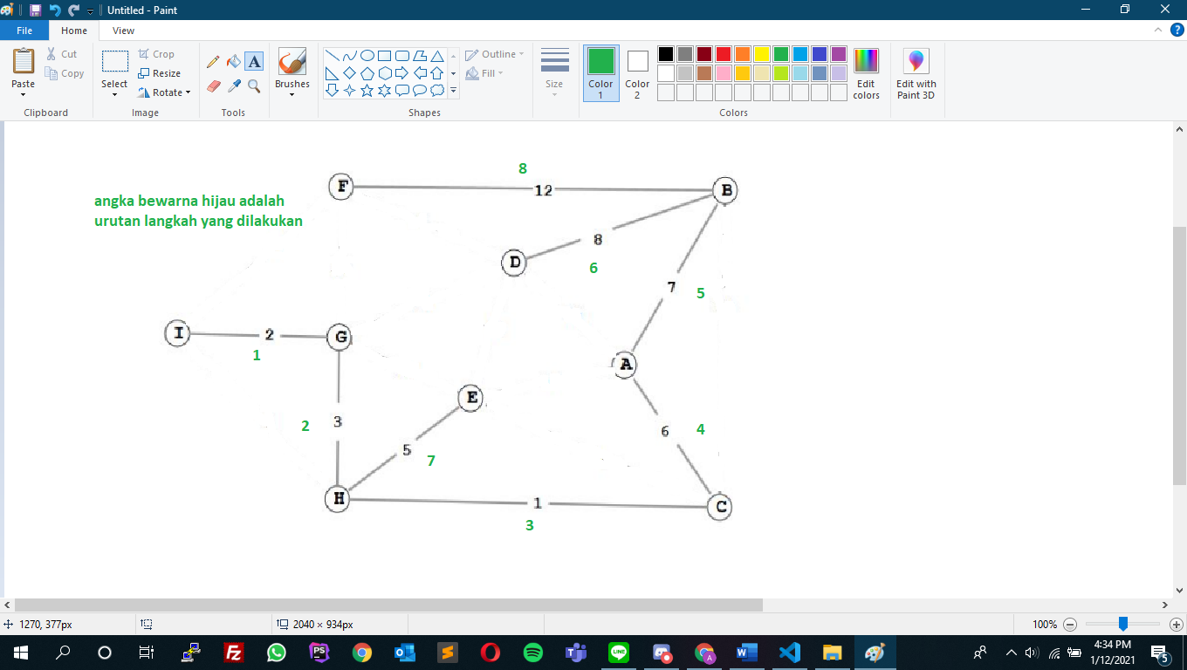

Total cost = 44

Djikstra algorithm

I to A

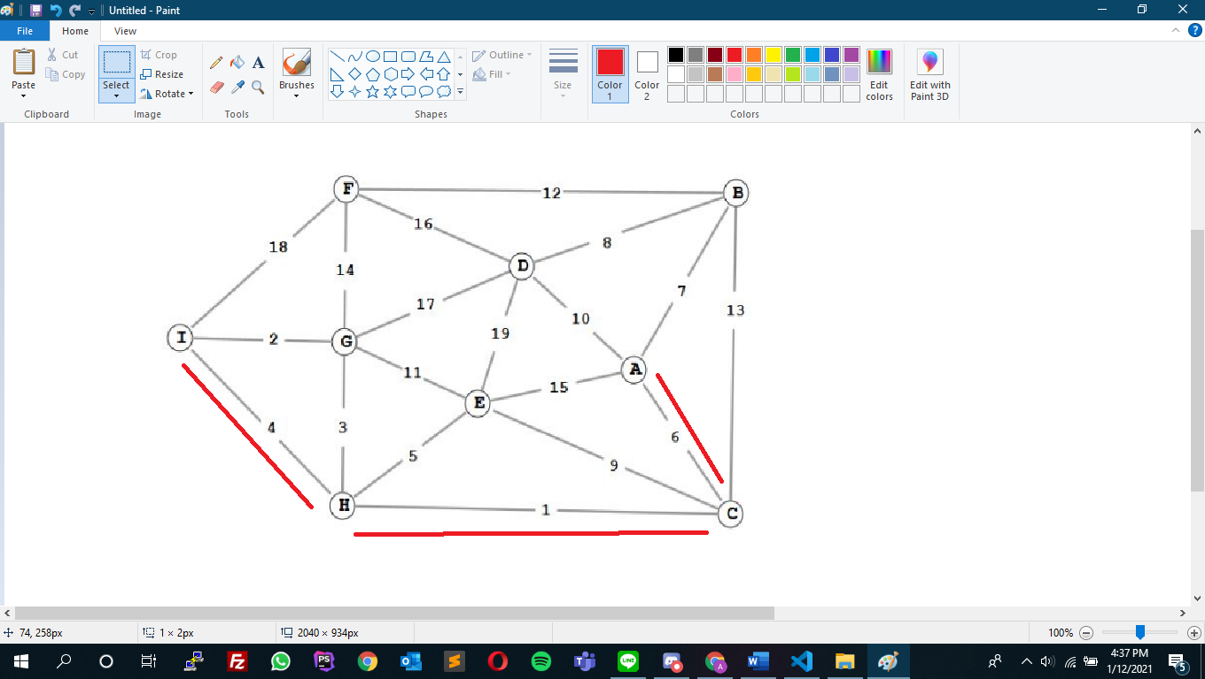

Arah nya I-H-C-A

Total cost = 11

F to C

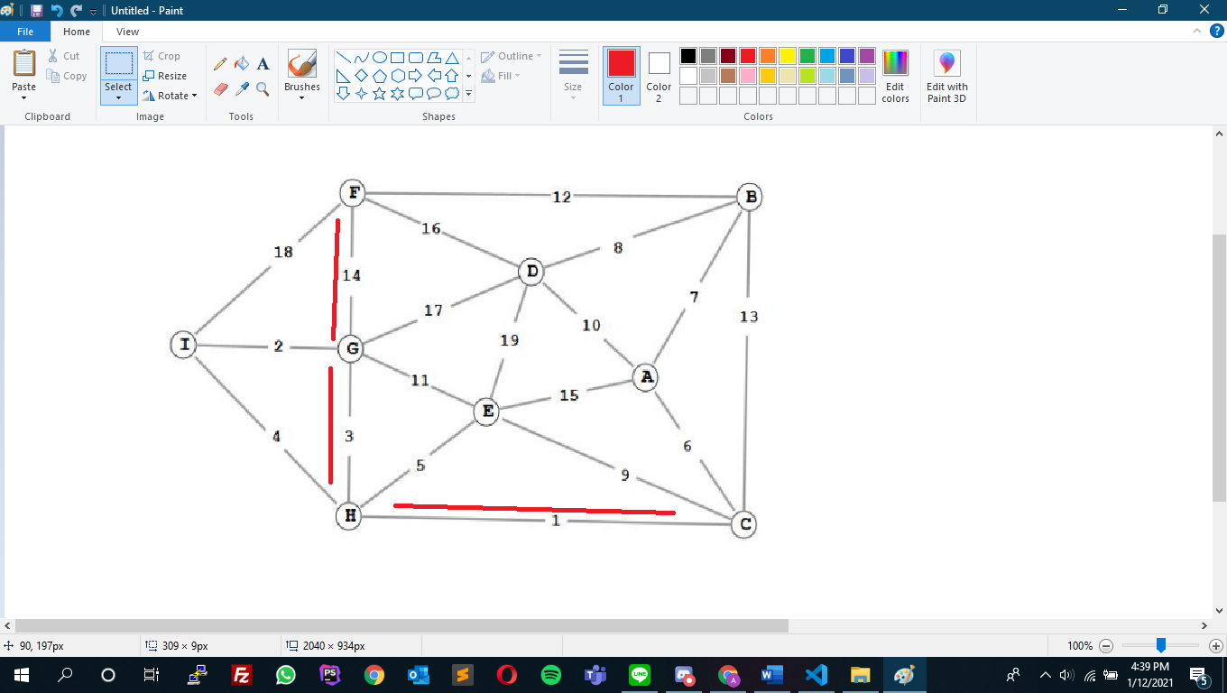

Arah nya F-G-H-C

Total cost = 18